Clinician Reference Sheet (Aug 2017 Guidelines)

Supplements |  | Daily dose
 |  | Band |  | RYGB & SG
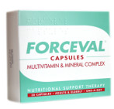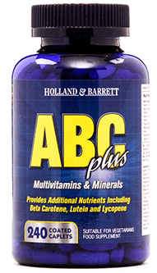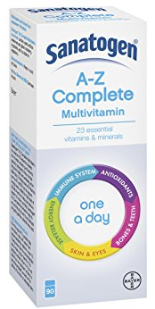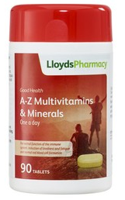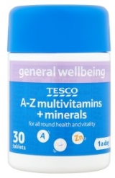 | A-Z complete vitamin and mineral supplement  Forceval capsule (preference)  Suitable alternatives:  Band -  Holland & Barrett ABC Plus. Other options but contain less folic acid: Sanatogen A-Z Complete; Tesco A-Z multivitamin and mineral; Lloyds Pharmacy A-Z Multivitamin and Minerals  Bypass & Sleeve -  Holland & Barrett ABC Plus;  Sanatogen A-Z Complete;  Tesco A-Z multivitamin and mineral; Lloyds Pharmacy A-Z Multivitamin and Minerals | Once a day |  | One, twice a day
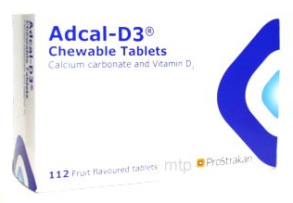 | Combined calcium and vitamin D supplement  Adcal D3 (preference)  Suitable alternatives:  Shops equivalent. | Adcal D3: One, twice a day  Alternative: Dose to provide 1000mg & 20ug (800IU) vitamin D/day.
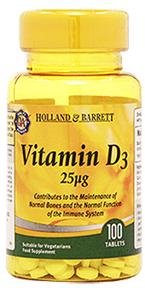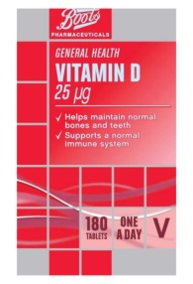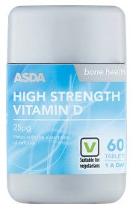 | Vitamin D (D3)  Widely available in shops, recommend 25ug (1000IU)/caplet | Dose to provide total of 50ug (2000IU) a day  i.e. 25ug (1000IU) twice a day
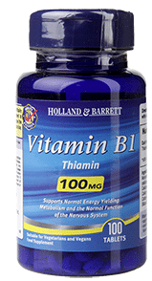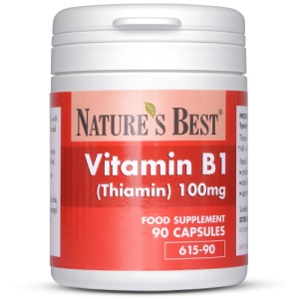 | Thiamine (vitamin B1)  Recommended dose is 50mg/day but only widely available in shops in 100mg. So can split 100mg tablet and take ½ a day, take 100mg daily or take 100mg every other day.  See note below re. increase dose if high risk. | 50-100mg a day for first 2 years*
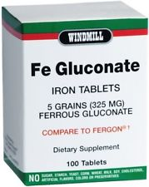 | Iron  Ferrous Gluconate.  Equivalent can be considered, advise pt to s/w GP/dietitian. | Not routine unless clinically indicted | 300mg once a day
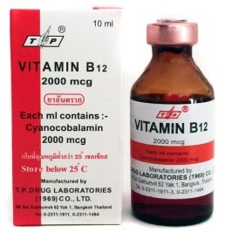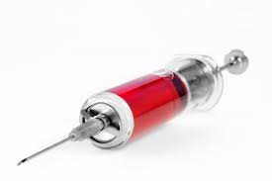 | Vitamin B12  Hydroxocobalamin injection at GP surgery.  Oral or sublingual vitamin B12 supplements not recommended as no long term data. | Not routine unless clinically indicted | 1mg injection every 3m, start 6m post op.  Still continue if blood tests normal.
PLANNING AND DURING PREGNANCY: Changes required, refer to Trust Guidelines.
PROLONGED VOMITING/CONCERNS RE. ALCOHOL INTAKE: In addition to above 1. Thiamine, total of 200mg once a day (*increase dose to 200mg if in first 24/12, restart if >12/12) 2. Vitamin B Co Strong, one tablet, three times a day 3. Refer to Bariatric Dietitian.

