Vesak (or Wesak) Information Sheet
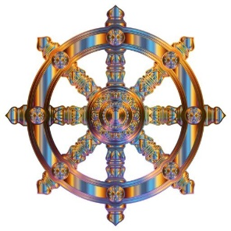
May 26th 2021

In Buddhist tradition, Vesak is the most important of the Buddhist festivals. It is a celebration of the Buddha's birthday and, for some, also marks his death and enlightenment.

What do people do during Vesak?
- The celebration of Vesak may vary from one Buddhist country and culture to another.
- Many Buddhists will gather at year temple before dawn for the hoisting of the Buddhist flag
- Many Buddhists will bring offerings and share food
- Buddhists may make time to carry out additional time for extra mediation, chanting and prayer, reflecting on Buddhist teaching
- Many Buddhists may already be vegetarian, but some will make an extra effort not to eat meat or fish during Vesak.
- Celebrations vary according to local tradition but may include decorating houses with paper lanterns, taking part in processions or wearing special white clothes.
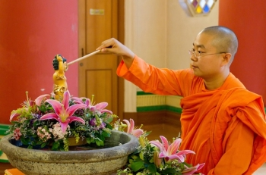
- The ‘Bathing the Buddha’ ceremony may take place. Water is poured over the shoulders of the Buddha as a reminder to purify the mind from greed, hatred and ignorance.

Implications for patients and staff
It may be helpful at this time to provide a quite space for meditation and prayer
Ensure vegetarian meal choices are available during his time.

If you would like more information or support, please contact the chaplaincy teams: Community and Mental Health Team: chaplaincy.community@somersetft.nhs.uk
Musgrove Park Hospital Team: chaplaincy.acute@somersetft.nhs.uk

