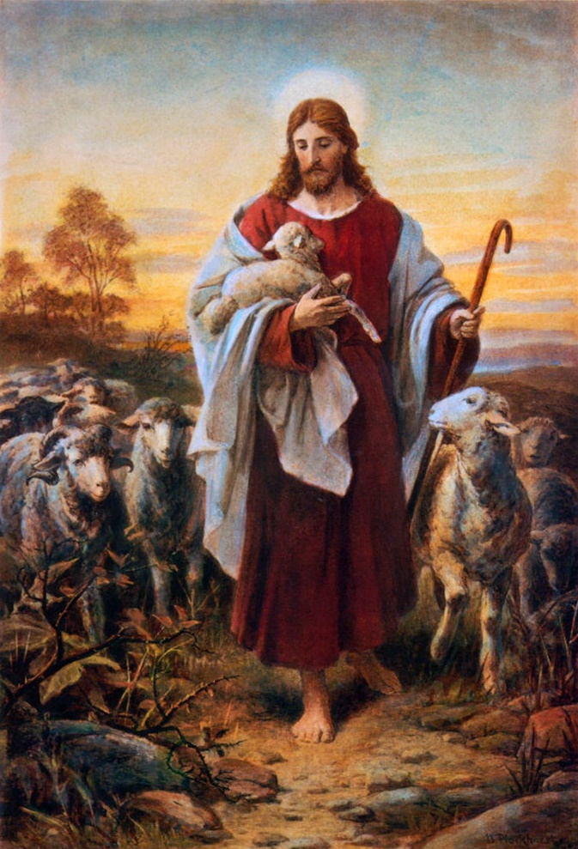

Psalm 23

The Lord is my Shepherd - King James Version

The Lord is my shepherd; I shall not want.
He maketh me to lie down in green pastures:
he leadeth me beside the still waters.
He restoreth my soul:
he leadeth me in the paths of righteousness for his name's sake.
Yea, though I walk through the valley of the shadow of death, I will fear no evil: for thou art with me; thy rod and thy staff they comfort me.
Thou preparest a table before me in the presence of mine enemies:
thou anointest my head with oil; my cup runneth over.
Surely goodness and mercy shall follow me all the days of my life:
and I will dwell in the house of the Lord for ever.

