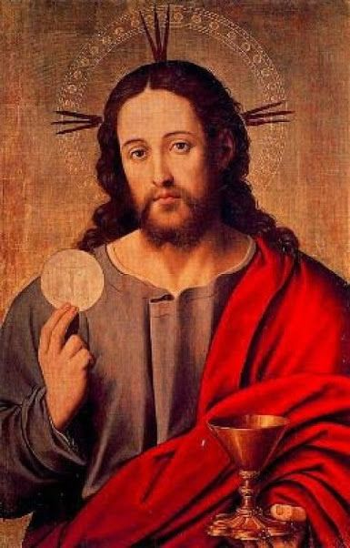

What to do when we cannot attend Mass
Nothing can come between us and the love of Christ
Rom 8:31-39
What Should I do if I Can’t go to Mass?

Follow Mass on-line
To follow the Mass celebrated by Pope Francis:
https://www.vaticannews.va/en

Masses and Services elsewhere:
https://www.churchservices.tv/whats-on-now/

We are encouraged to make a ‘spiritual communion’ as it will strengthen our “desire for the sacrament of the Eucharist” (St John Paul II). Saint Teresa of Jesus wrote: ‘When you do not receive communion and you do not attend Mass, you can make a spiritual communion, which is a most beneficial practice; by it the love of God will be greatly impressed on you.’”

How Do I Make a Spiritual Communion?

Alone or together with others in your household

- Make the sign of the cross
- You could read the Gospel of the day
- Then share prayer intentions quietly or aloud
- Say the Lord’s Prayer
- Then make an act of spiritual communion

My Jesus, I believe that You are present
in the Most Holy Sacrament.
I love You above all things,
and I desire to receive You into my soul.
Since I cannot at this moment receive You sacramentally, come at least spiritually into my heart.

I embrace You as if You were already there
and unite myself wholly to You.
Never permit me to be separated from You.
Amen.

St. Alphonsus Liguori

- Close with the sign of the cross.
A Prayer in Time of Danger and Illness
God Our Father,
each person is precious to You.
You are the Giver of life.
Have mercy on us and protect us
at this time, as the Coronavirus
threatens health and life.
You are an ever-present Helper
in time of trouble.
Watch over those who are
suffering, give strength to those
who are aiding the Sick and give courage
to all in this time of anxiety.
We ask this of you in the name of your Son Jesus Christ.
Amen

A prayer for all those affected by coronavirus

Keep us, good Lord,
under the shadow of your mercy.
Heal the sick!
Sustain and support the anxious.
Be with those who care for the sick,
and lift up all who are brought low;
that we may find comfort
knowing that nothing can separate us from your love
in Christ Jesus our Lord.
Amen.

“Make mercy the air you breathe”
Pope Francis

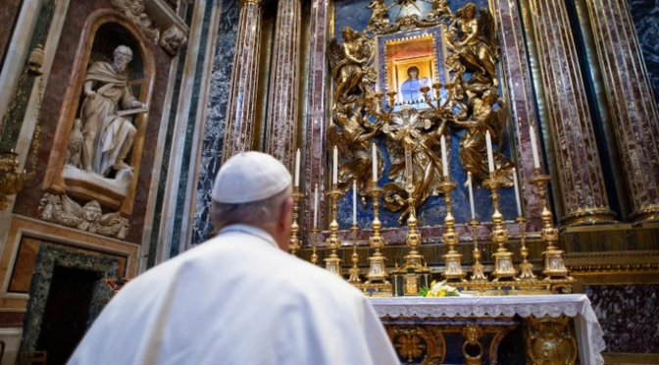

St Mary Major, Rome: Salus Popoli Romani

Pope Francis’s Prayer to Mary during Coronavirus Pandemic

O Mary, you always shine on our path as a sign of salvation and of hope. We entrust ourselves to you, Health of the Sick, who at the cross took part in Jesus’ pain, keeping your faith firm.

You, Salvation of Your People, know what we need, and we are sure you will provide so that, as in Cana of Galilee, we may return to joy and to feasting after this time of trial.

Help us, Mother of Divine Love, to conform to the will of the Father and to do as we are told by Jesus, who has taken upon himself our sufferings and carried our sorrows to lead us, through the cross, to the joy of the resurrection. Amen.

Under your protection, we seek refuge, Holy Mother of God. Do not disdain the entreaties of we who are in trial, but deliver us from every danger, O glorious and blessed Virgin. Amen.
(Adapted from Vatican News.)

