Jewish Holidays in September and October 2021

Some general information:
- All festivals begin before dusk and end at nightfall.
- A family may wish to discuss a patient’s medical treatment with a Rabbi.
If they do not have links to their own Rabbi, hospital staff can contact the chaplains, who will make every effort to put the family in touch with a religious leader.
For all enquiries relating to Community and Mental Health please email: chaplains.community@somersetft.nhs.uk
For the chaplaincy team at Musgrove please email: chaplains.acute@somersetft.nhs.uk
- Shabbos laws: During many days of the festivals Jewish people will follow similar laws as on the Shabbos (Sabbath). Please be aware of and sensitive towards patients and their families, who are not allowed to operate any electrical switches (beds, lights, switches to open doors, use a telephone, etc.), travel by car, carry keys, handle money, sign consent forms (verbal consent may be an option), run hot water, etc.
Some patients may request early discharges so that they can be home in time for the beginning of the festival.

Rosh Hashanah – New Year:
(literally “Head of the Year”) = the Jewish New Year of 5782
Monday 6th Sept 2021 (sunset) – Wednesday 8th Sept (sunset)

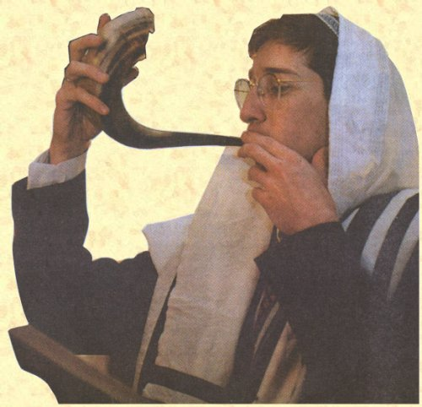

Background:
In the hope that the New Year will be sweet it is customary to eat an apple dipped in honey. However the days leading up to the New Year as well as the two days of the New Year are solemn days, where people spend much time in the synagogue, praying and reflecting on their lives.
The ram’s horn (shofar) is blown to remind God of his mercy towards Abraham and his descendants.
Implications for staff and patients:
Most patients will want to adhere to the same laws as on the Shabbos (Sabbath).
Patients will draw great comfort from hearing the shofar.
Yom Kippur – Day of Atonement:
Wednesday 15th September (sunset) to Thursday 15th September (sunset)

Background:
This is probably the most solemn of all days in the Jewish calendar.

Implications for staff and patients:
Most patients will observe the shabbos rules and will want to hold a complete fast for the duration of Yom Kippur. They will not want to drink or eat anything. Dispensation for fasting may be sought from a Rabbi for patients where fasting might compromise their health.

Sukkoth – Tabernacles
Monday 20th September (Sunset) – Monday 27th September (Sunset)
Traditionally, the first thing we do after we have heard the shofar blast and broken our fast is to begin to build a Succah (booth)

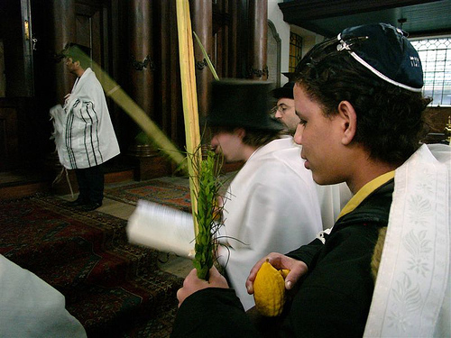

Background
During this festival people are reminded of the exodus and walking through the wilderness for 40 years. During this time they had no permanent home and ate all their meals outside. However G-d provided them with shelter and shade as His cloud hovered above them all throughout their journey.
During this time men are obliged to eat all meals outside.
Often a special Sukkah is built outside the home, where people can eat their meals.

Families may bring in palm branches, which are waved to symbolize G-d’s all encompassing presence and mercy.

Thank you very much for your understanding and cooperation

