Speech Sound Screener
Please complete this Speech Sound Screener, if you are concerned about your child’s pronunciation and they are over three years old.
It will help you to work out which sounds your child is having difficulty saying and whether these sounds should have developed at their age. Please fill it in the best you can.
Over the page you will find some pictures and a record form. Show your child each picture and ask them to tell you what it is called. If they are not sure, you could give them a choice e.g. “Is it a pig or a banana?”
Write down how your child says the word e.g.
Target word | How your child says the word:
pig | big
car | tar

If after completing the Speech Sound Screener you feel a referral to Speech and Language Therapy is needed, please ensure you attach the record form to your referral as it will not be considered at triage without it. The referral form can be found on our website:
https://www.somersetft.nhs.uk/children-and-young-peoples-therapy-service/sample-page/how-to-refer-a-child-or-young-person/

Speech Sound Screener Record Form

Child’s name: Date of birth: Date completed:

Name and role of person completing this with the child:

Early sounds in typical order of development. |  | Later Sounds - Many of these will not be fully established until the age of 5 or 6
Target word: | Write how your child says the word: | Target word: | Write how your child says the word:
pig |  | sheep
bird |  | chair
mouse |  | jam
knife |  | snail
window |  | smile
teddy |  | swing
dice |  | lion
car |  | rabbit
girl |  | blue
fish |  | plate
van |  | clown
sock |  | bread
zebra |  | present
 |  | frog
Can you understand your child’s talking? (please circle)

Most of the time / Some of the time / All of the time

Any other comments:

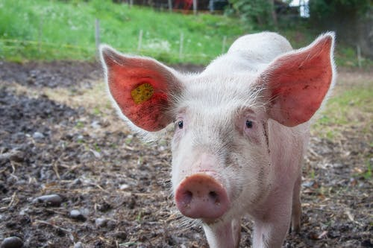 | 
 | 

 | 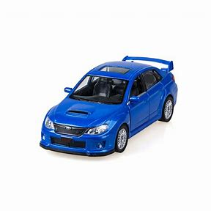 | 
 | 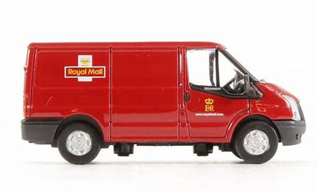 | 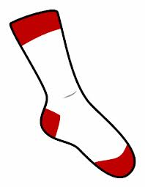
 | 