FODMAP Diet
for Irritable Bowel Syndrome (IBS)

NOTE: The low FODMAP diet is extremely effective in roughly 70% of patients with symptoms of IBS. However it is a complex diet to tackle without the appropriate help. Careful implementation of a low FODMAP diet is needed to ensure that the diet is effective and nutritionally adequate. Effective education should be given by FODMAP trained dietitians.

What is the FODMAP Diet?

Some carbohydrates may contribute to IBS symptoms. These carbohydrates are called Fermentable Oligo-saccharides, Di-saccharides, Mono-saccharides, And, Polyols. [1,2] Also known as FODMAPS.

NB: ONLY these carbohydrates are a problem and NOT all carbohydrates.

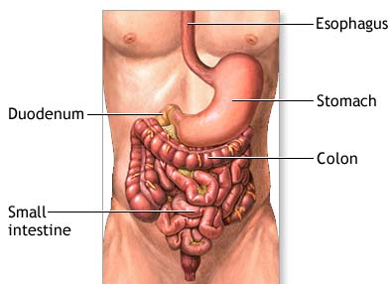
These particular carbohydrates are not absorbed in the small intestine and so create food residue. This food residue passes out of the small intestine and into the large intestine (colon) where it is then fermented by the bacteria in this area of the gut.

The fermentation of this food residue in the colon can cause gas producing symptoms such as wind, bloating, abdominal pain and can alter stool consistency resulting in diarrhoea. [1,2,3]

SUMMARY: FODMAPs are dietary carbohydrates, which are poorly absorbed in the small intestine and fermented in the large intestine triggering symptoms in sensitive individuals. [1,2,3]

Dietary intervention

Dietary intervention involves the strict elimination of FODMAP foods for an 8 week period.

FODMAP containing foods are then reintroduced to identify which particular FODMAPs you are most sensitive to. Different individuals will be more sensitive to certain FODMAPs.

Foods are often well tolerated after this period of elimination and the majority of individuals will not need to be too restrictive for the long term. [3]

NOTE: PLEASE be aware of using information from the internet as this is not always reliable or complete and may lead to frustration and poor results.

Is this an allergy diet?

No. IBS is caused by irregular gut function e.g. bacteria fermenting food residue when there are too many FODMAPs in the diet. Hence, IBS is also called ‘functional gut syndrome’. IBS sufferers can often tolerate small to moderate amounts of the suspect foods.

Food allergy, on the other hand, involves the immune system and the body may react to tiny amounts of the suspect food. The immune system is not involved in IBS. Hence IBS is not an ‘allergy’ to foods.

NOTE: This information is intended as educational and not as a treatment programme. Please consult a specialist dietitian and/or doctor for guidance before altering dietary intake.

references
- Gibson PR, Sherher SJ, Food choice as a key management strategy for functional gastrointestinal symptoms. American Journal of Gastroenterology; 107 (2012): 657-666
- Staudacher H, Whelan K, Irving PM, Lomer M, Comparison of symptom response following advice for a diet low in fermentable carbohydrates (FODMAPs) versus standard dietary advice in patients with irritable bowel syndrome. Journal of Human Nutrition & Dietetics: 24 (2011); 487-495
- Gibson PR, Shepherd SJ, Evidence-based dietary management of functional gastrointestinal symptoms: The FODMAP approach. Journal of Gastroenterology and Heptology; 25 (2010); 252-258
- Barrett JS, Gibson PR, Clinical ramifications of malabsorption of fructose and other short-chain carbohydrates. Practical Gastroenterology: 53 (2007); 51-65
- Guys & St Thomas’ NHS Foundation Trust & Kings College London, 2010, Reducing Fermentable Carbohydrates the low FODMAP way. (Booklet – available via your dietetic consultation)

Also of interest is: British Dietetics Association, 2010, UK Evidence-based practice guidelines for the dietetic management of irritable bowel syndrome in adults. Professional Guideline. Birmingham, UK.

PLEASE NOTE: This information is intended as educational and not as a treatment programme. Please consult a specialist dietitian and/or doctor for guidance before altering dietary intake.

