
Name: | Click or tap here to enter text.
Hospital Number: | Click or tap here to enter text.

Health Passport
Adult Services

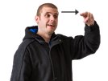   | Name: (I like to be called) |  |  |  |  |  |  |  |  |  | Hospital Number:
 | Click or tap here to enter text. |  |  |  |  |  |  |  |  |  | Click or tap here to enter text.
 | Address: |  |  |  |  |  |  | 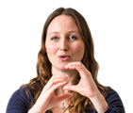   |  |  | Date of birth:
 | Click or tap here to enter text. |  |  |  |  |  |  |  |  |  | Click or tap here to enter text.
 | Telephone number: |  |  |  |  |  |  |  |  |  | Language I use to communicate:
 | Click or tap here to enter text. |  |  |  |  |  |  |  |  |  | Click or tap here to enter text.
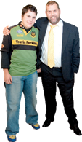 | Next of kin: | Click or tap here to enter text. |  |  |  |  |  |          |  |  | Religion:
 | Address: | Click or tap here to enter text. |  |  |  |  |  |  |  |  | Click or tap here to enter text.
 | Phone number: | Click or tap here to enter text.
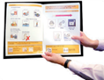 | Any Relevant Care Plans / Forms. (Please bring these with you)
 | Eating and drinking |  |  |  |  |  |  |  |  |  |  |  |  | ☐
 | End of life |  |  |  |  |  |  |  |  |  |  |  |  | ☐
 | Other |  |  |  |  |  |  |  |  |  |  |  |  | ☐
 | People involved in your care: ( named consultants, neurologists, health, social care, GP)
 | Click or tap here to enter text.
  Completed by: (Name) | Click or tap here to enter text. |  |  | 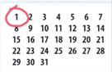  Date: | Click or tap here to enter text. |  |  |  |  |   Signed: |  | Click or tap here to enter text.
Mental capacity Act 2005
If I am assessed as lacking capacity and not able to make decisions about my treatment or discharge planning when I am in hospital, the following people must be contacted in any decisions made in my best interest.
Name |  |  | Relationship |  |  |  | Contact details |  |  |  |  |  | Lasting power of attorney please circle
Click or tap here to enter text. |  |  | Click or tap here to enter text. |  |  |  | Click or tap here to enter text. |  |  |  |  |  | Finance / Welfare
Click or tap here to enter text. |  |  | Click or tap here to enter text. |  |  |  | Click or tap here to enter text. |  |  |  |  |  | Finance / Welfare
Click or tap here to enter text. |  |  | Click or tap here to enter text. |  |  |  | Click or tap here to enter text. |  |  |  |  |  | Finance / Welfare
Click or tap here to enter text. |  |  | Click or tap here to enter text. |  |  |  | Click or tap here to enter text. |  |  |  |  |  | Finance / Welfare
Essential information
Very important information you must know about me
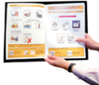 | Diagnosis and medical conditions: (Including Autism)
 | Click or tap here to enter text.
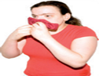 | Allergies:
 | Click or tap here to enter text.
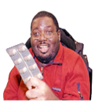 | Medication: (Please always bring a list of the medication you take)  How do you take your medication and what time do you take it?
 | Click or tap here to enter text.
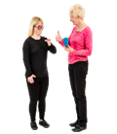 | How I communicate: ( verbal, non-verbal, braille, written, sign language)
 | Click or tap here to enter text.
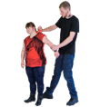 | Behaviours that may cause risks to self, others or the environment: (biting, head-butting, harming myself)
 | Click or tap here to enter text.
 | Triggers that may lead to behaviours that challenge and ways to support me:  (changes in routine)
 | Click or tap here to enter text.
 | Pain / distress indicators and how to make medical test easier: (How do you show you’re in pain. How can staff support you during medical tests)
 | Click or tap here to enter text.
 | Important routine and keeping safe: (Do you require supervision during a hospital stay? What routines do you have at home)
 | Click or tap here to enter text.
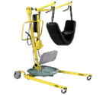 | Equipment, setting and sizes (positioning, hoist, bed rails, trachy/NG size, ventilation settings)
 | Click or tap here to enter text.
 | Previous admissions and procedures (i.e. implants such as a pacemaker or VNS, Do you have any metal plates, have you had any operations before?)
 | Click or tap here to enter text.
 | If you are having a general anaesthetic are there any other procedures that can be done at the same time? (I;e, toe nails being cut whilst having a general anaesthetic for dental surgery)#
 | Click or tap here to enter text.
Important Information
Important information about my general living
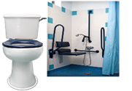 | Support needs: (Washing and dressing, toilet needs, personal hygiene)
 | Click or tap here to enter text.
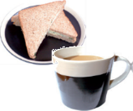 | Eating and drinking (support required, temperature, texture, equipment, likes, dislikes. Please read my eating and drinking care plan if I have one.)
 | Click or tap here to enter text.
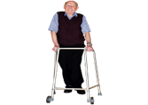 | How I move around: (Wheelchair, frame, hoist, walk)
 | Click or tap here to enter text.
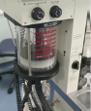 | Breathing (asthma, sleep apnea)
 | Click or tap here to enter text.
 | Expressing emotions (how do you express if you are happy, sad, worried, scared?)
 | Click or tap here to enter text.
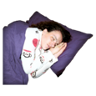 | Sleeping (do you have a routine, sensory needs)
 | Click or tap here to enter text.
Have you got any problems with your:
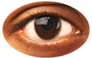  Sight | Click or tap here to enter text. |  |  |  |  | 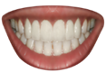Teeth |  |  | Click or tap here to enter text.
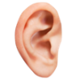  Hearing | Click or tap here to enter text. |  |  |  |  | 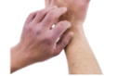  Skin |  |  | Click or tap here to enter text.
Preferable information

What will make my hospital stay better
 | Things you like and things that make you happy:
 | Click or tap here to enter text.
 | Things you dislike and things that may upset you:
 | Click or tap here to enter text.
 | Things that will make your hospital stay better:
 | Click or tap here to enter text.




Traffic Light System

RED
Essential information

This is very important information you must know about me!
Within the red section above, should include the extremely important information health care staff should need to know about you.

In addition to this, if the red section does not cover what you see as really important information please use the additional space below to record.

Within the amber section above, should include the important information with regards to general living tasks that health care staff should need to know about you.

In addition to this, if the amber section does not cover what you see as information that staff need to be aware of please use the additional space below to record.
AMBER
Important information

This is important information about my general daily living.

GREEN
Preferable information

This is information about my likes, dislikes and how best to comfort me.
Within the green section above, should include the
Information health care staff should need to know about you that will help them to know you a little bit more.

In addition to this, if the green section does not cover what you see as really important information please use the additional space below to record.

Additional Information

Click or tap here to enter text.
Click or tap here to enter text.
Click or tap here to enter text.
RED
Essential information

This is very important information you must know about me!
AMBER
Important information

This is important information about my general daily living.
GREEN
Preferable information

This is information about my likes, dislikes and how best to comfort me.
This hospital passport can be found on the Sompar public website and by searching Learning Disabilities or alternatively by calling 01823 668790 and somebody will be able to help you.

Image © Copyright 2006 photo symbols Ltd. All rights reserved.

This Health Passport has been adapted by Somerset Partnership NHS foundation Trust and is based on the original Hospital passport by Gloucestershire NHS Trust.

The aim of this Health Passport is to provide all health care staff with necessary information that may be required during health appointments or hospital admissions. It will help health care professionals to meet your needs to ensure you are getting the care you require.

Please take this document with you to health appointments or hospital admissions.
Please ensure that this document is kept up-to-date and reviewed regularly. This document is your responsibility to keep up to date and not the responsibility of the Learning Disability Service.

