Mendip
Specialist Nurse – Sarah Mabbott
Health Link Worker – Emma Morgan

Wells Shepton
Elim Centre Gracie House
Spencer House
Keward House Street
The Bridge Foyer YMCA
Baptist Church

Glastonbury Frome
Red Brick Building YMCA
Cinnamon Lane
Sedgemoor
Specialist Nurse – Freya Norton
Health Link Worker – Josh Purkis

Bridgwater Highbridge
Westfield Church Highbridge Hotel YMCA
Blake Place Wade House
Gerald Townsend YMCA
Edinburgh Road
Richard Milton House

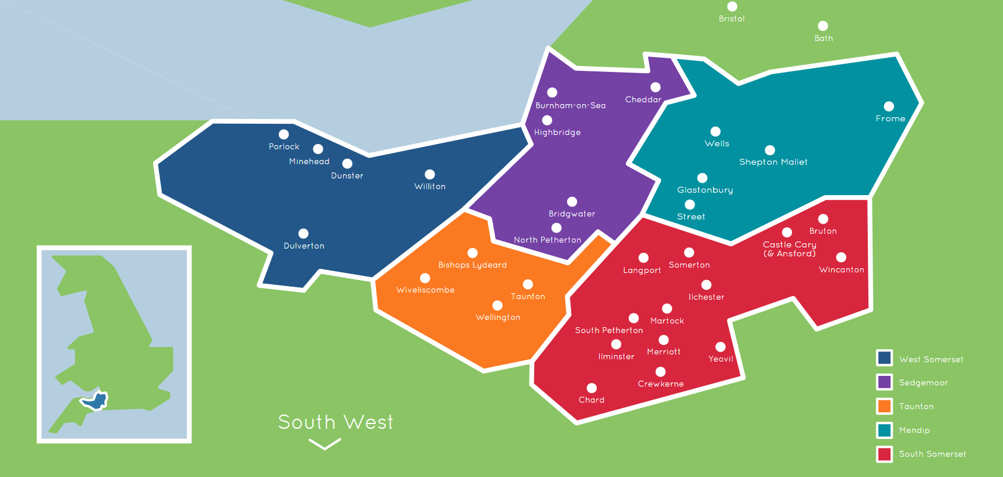
Somerset West & Taunton
Specialist Nurse – Justine Brunton
Health Link Worker – Louise Jackson

Taunton
Open Door
Canonsgrove
Lindley House
Victory House
Kilkenny Court

South Somerset
Specialist Nurse – Georgina Higgins
Health Link Worker – Kat Patman

Yeovil Chard
Pathways Crimchard
Gateway
The Link
Julian House Properties
Karen George – Clinical Lead
Lucy Williams - Administrator

