Employee Assistance Programme (EAP)
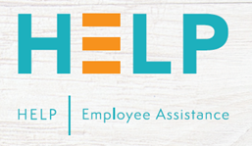
HOW CAN WE HELP YOU?
Emotional, health and social problems can affect many of us from time to time. They can cause great personal distress and affect our quality of life, both at home and at work. The Employee Assistance Programme (EAP) provides professional support and guidance for employees and immediate family* experiencing such issues.
CONFIDENTIALITY
Employees can trust that the Employee Assistance Programme treats all information
confidentially whether obtained directly or indirectly.
The employee assistance programme is provided by an external company and is bound by the professional code of ethics of the British Association for Counselling & Psychotherapy and the Employee Assistance Professionals Association.
THE EAP
If you are experiencing issues either at home or at work, the Employee Assistance
Programme (EAP) is on hand to provide you with expert guidance. Our team of wellbeing and counselling practitioners offer confidential, independent and unbiased information and guidance.
We provide this in a range of ways – by telephone, on-line and through face-to-face
appointments. We are available at any time of the night or day, 365 days of the year.
24 hours a day, 7 days a week Access a team of trained wellbeing and counselling practitioners to support all employees offering confidential, independent and unbiased information and guidance by telephone, in writing, online and through face-to-face appointments for a wide variety of issues.

CONTACT INFORMATION
contact us on 0800 032 9857
or for further information go to
https://somersetft.optimise.health
